Project 2

*Small Business Website*

# jACOBI’S RIVERSIDE DELI

<https://github.com/rachelofryer/Project_2>

# Outline

Jacobi’s Riverside Deli is a local NY style delicatessen located near the waterfront of the Ohio River. Specializing in locally-sourced fresh meats and side dishes. Specialty dishes rotate and Thanksgiving, Christmas, and Easter dinners can be ordered in their entirety. JRD also utilizes a food truck and offers catering services.

The target audience includes those of all ages, and is family-oriented. The price range caters to those in the middle class range (Yelp 3 dollar signs). All-inclusive environment, with strong family values.

The purpose of the website will be to direct potential customers to the shop itself, as well as order online, view the menu, contact the shop, view photos of the menu items and fare, and get the Jacobi's backstory.

The colour scheme is a deep red, creme, black, and white. Alternate colours include forest green (seasonal-Christmas) and pastel creme, salmon, and periwinkle (Jacobi's Kids Klub).

Project 2

*Small Business Website*

# Site Map

Project 2

*Small Business Website*

# Wireframes

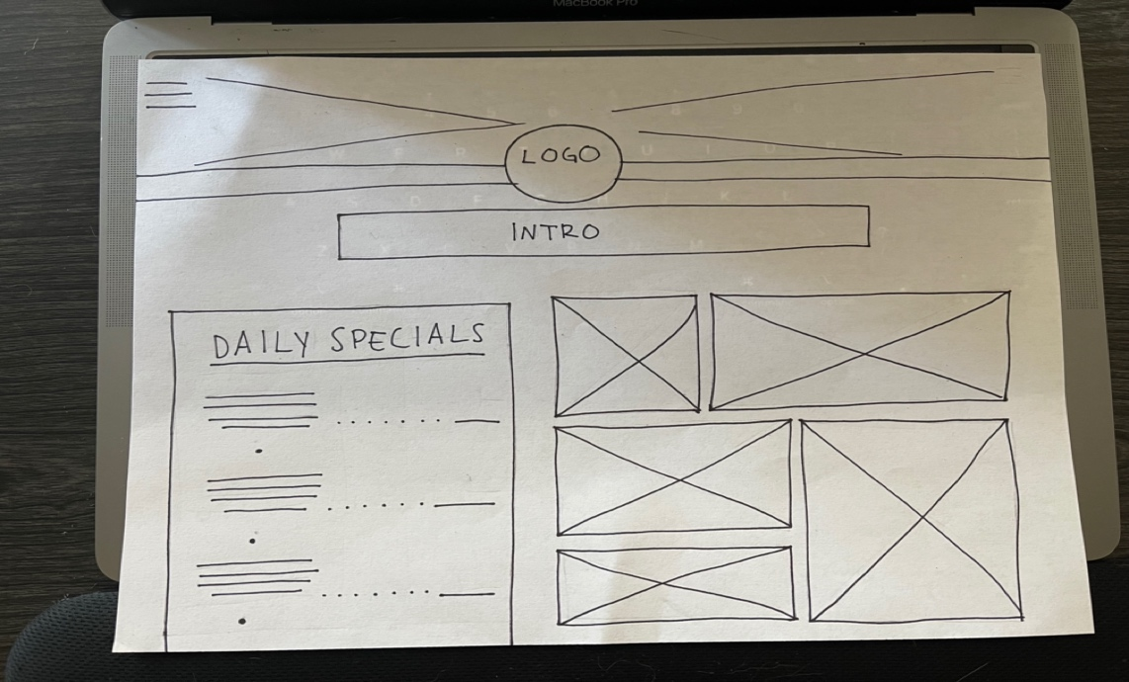

Project 2

*Small Business Website*

# Digital Mockups

Project 2

*Small Business Website*

# Notes

Baskerville Bold, size 47

*Baskerville Italic, Size 24*

# Baskerville Bold, Size 20



Use Heading 1 in the toolbar above will create the line under the text. Make sure to highlight the text and make it the correct size.

Paragraph text is Baskerville Regular, size 13.

If you do not have the Baskerville font, please use Georgia or similar, or work on this with our Macs.

You can download a free copy of Microsoft Office at:

<https://jefferson.kctcs.edu/news/microsoft-office-available-to-students-for-free.aspx>

Do not turn in this page. Keep it for your records.